- List the user commands and redirect the output to /tmp/commands.list
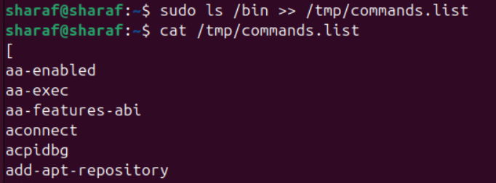
- Count the number of user commands
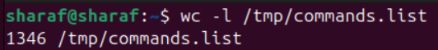
- Get all the users names whose first character in their login is ‘g’.
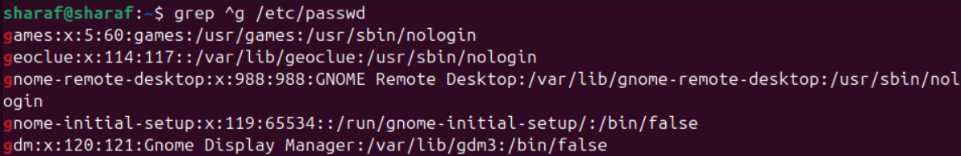
- Get the logins name and full names (comment) of logins starts with “g”.
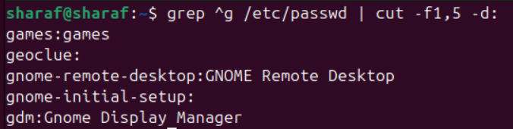
- Save the output of the last command sorted by their full names in a file.
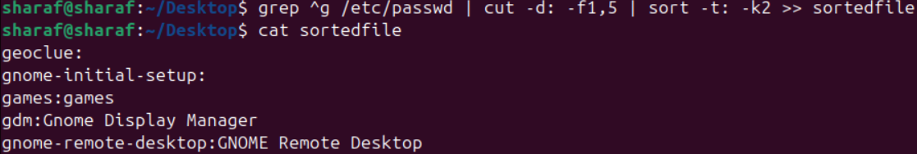

- Write two commands:
  - first: to search for all files on the system that named .bash_profile.
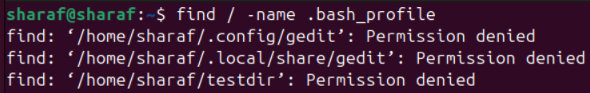
  - Second: sorts the output of ls command on / recursively, Saving their output and error in 2 different files and sending them to the background.
- Display the number of users who is logged now to the system.
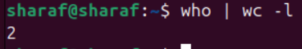
- Display lines 7 to line 10 of /etc/passwd file
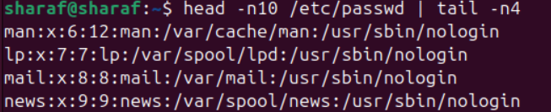
- What happens if you execute:
  - cat filename1 | cat filename2
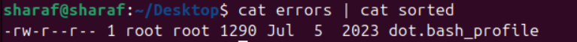
    - Display The Content Of Second File
  - ls | rm
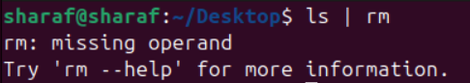
    - Require Operand For rm
  - ls /etc/passwd | wc –l
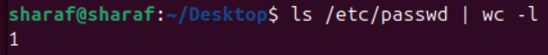

- Issue the command sleep 100.
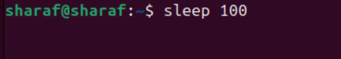
- Stop the last command.
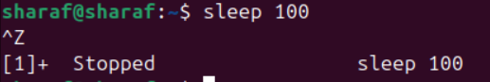
- Resume the last command in the background
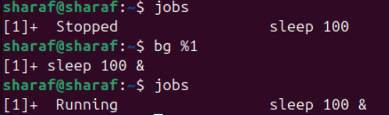
- Issue the jobs command and see its output.
- Send the sleep command to the foreground and send it again to the background.
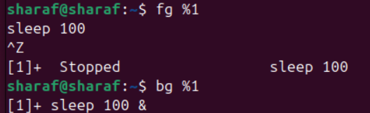
- Kill the sleep command.
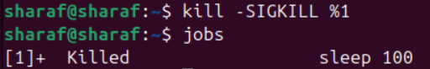

- Display your processes only
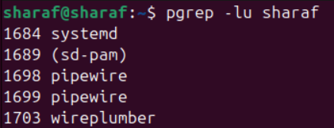
- Or
        - ps –u Sharaf
- Display all processes except yours
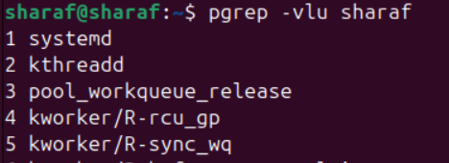
- Or
        - ps –d
- Use the pgrep command to list your processes only
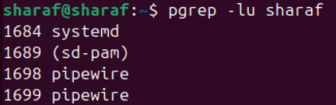
- Kill your processes only.
- Pkill –u Sharaf
- Killall –SIGKILL –u Sharaf



